**API GETWAY GET**

1. **Create a lambda function write the code and deploy it.**
2. 
3. Create event, lambda → functions → your lambda function → test → create event after test this event then its run successful.
4. 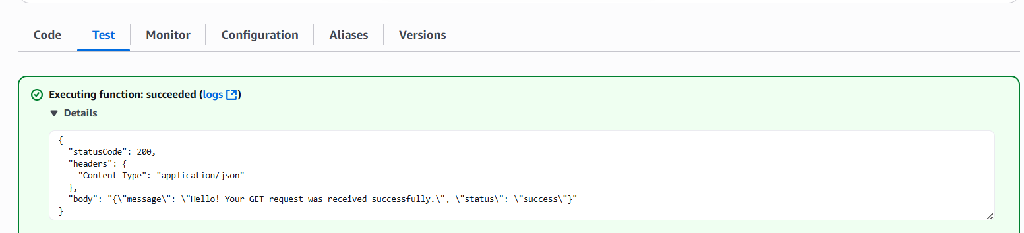
5. Now create api select http api.
6. Now integrate this api with lambda function, first create route select get and intergrate
7. 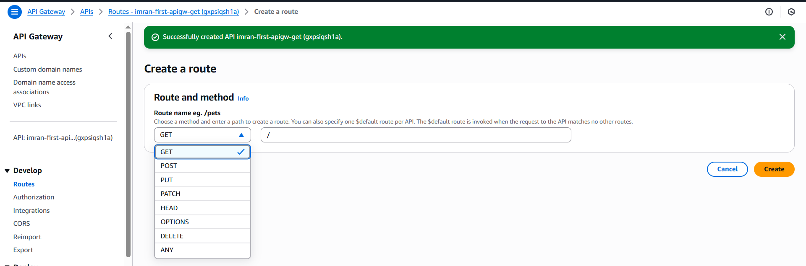
8. 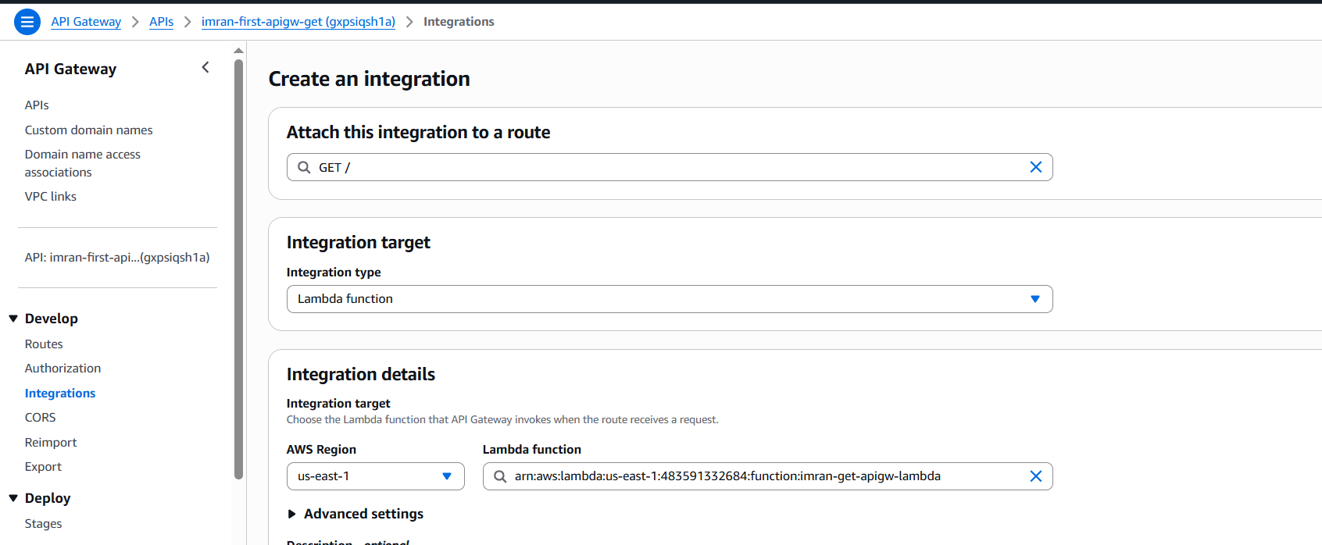
9. 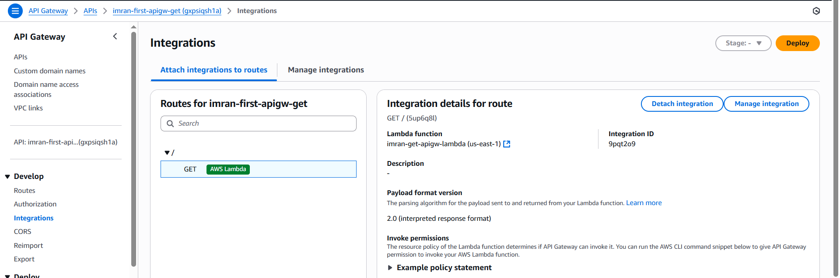
10. Now you need to take url of your api to access get api

<https://gxpsiqsh1a.execute-api.us-east-1.amazonaws.com/>

1. 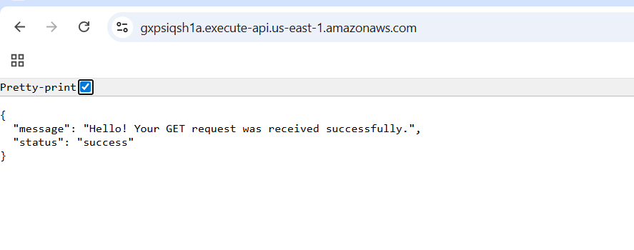
2. To check put and other methods install postman api software in laptop and check.
3. 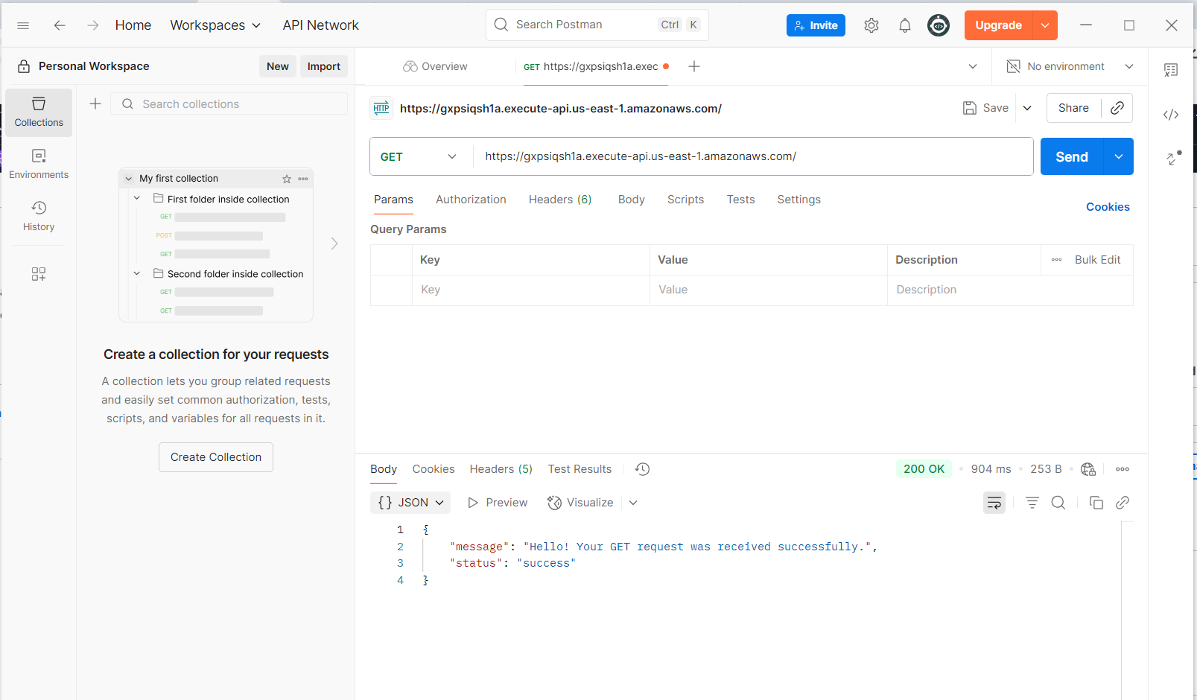

**TASK: Rest api for the non proxy integration**

1. Create a lambda function and write the code and deploy it and test.
2. 
3. 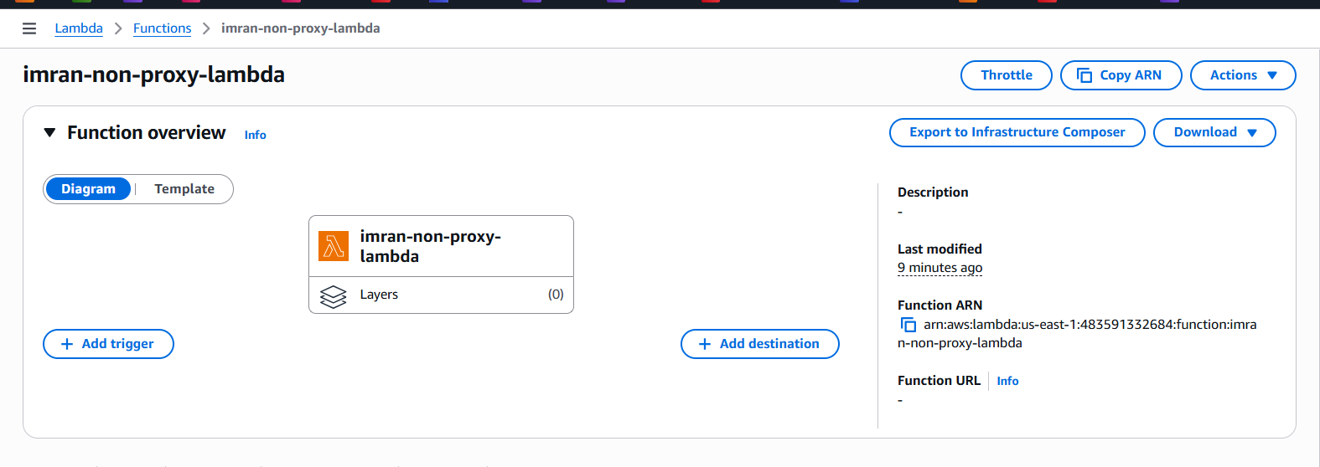
4. 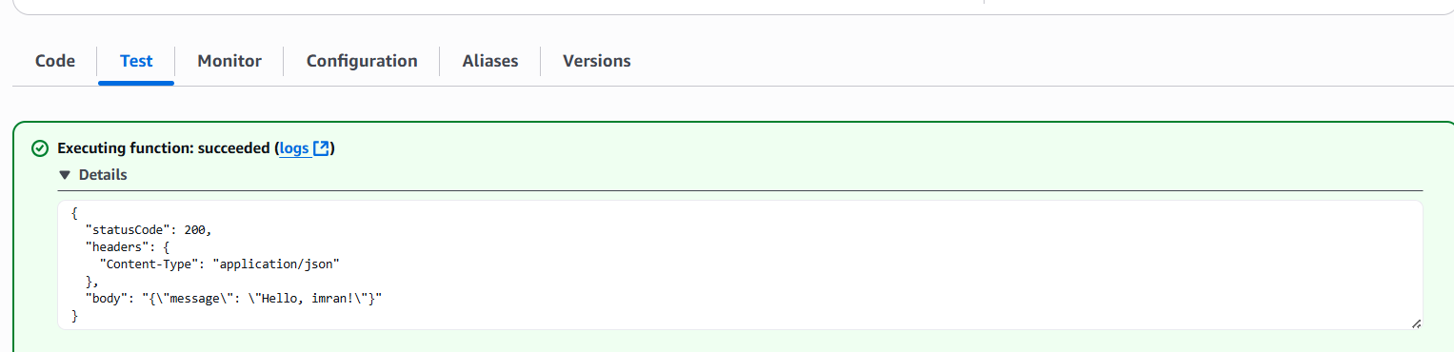
5. Now create api gateway using rest api
6. Then create resource and create method
7. 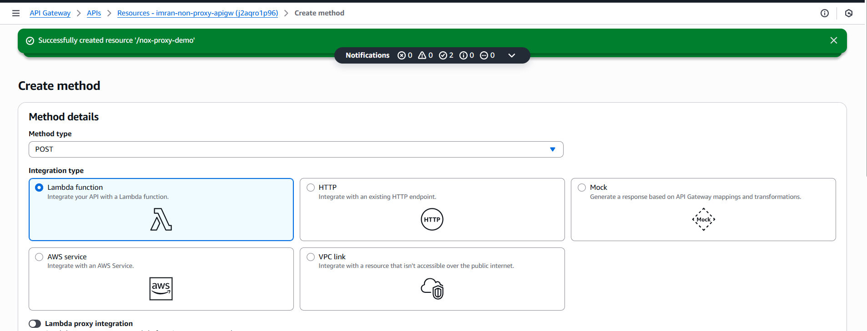
8. Now edit method request, integration request and save and deploy.
9. 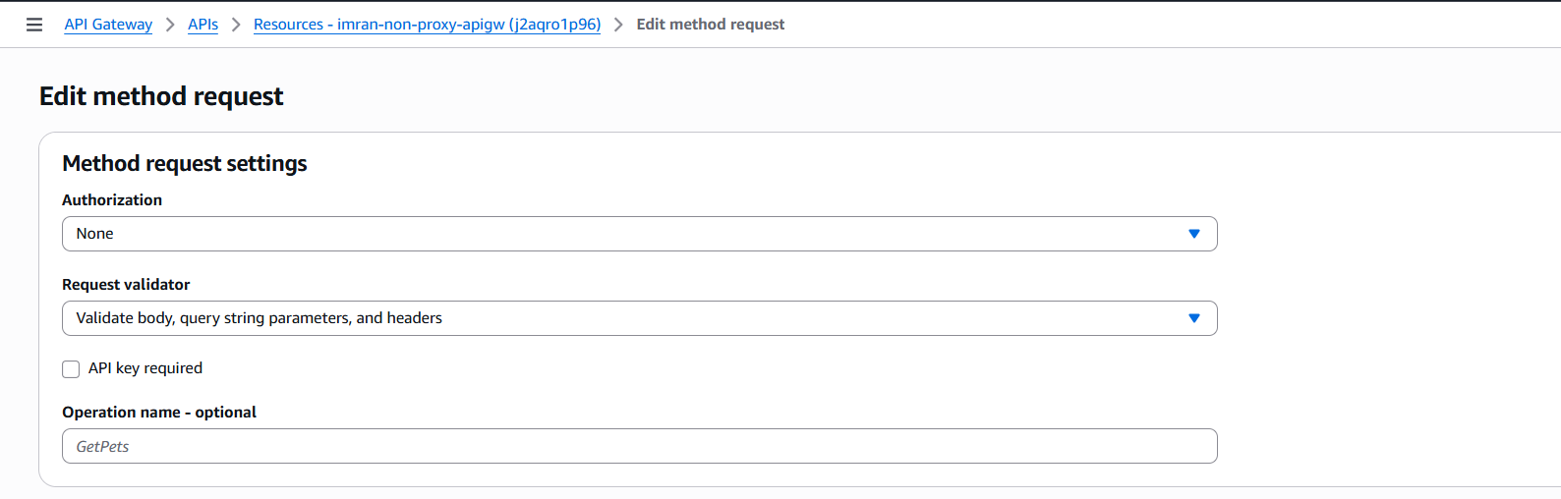
10. 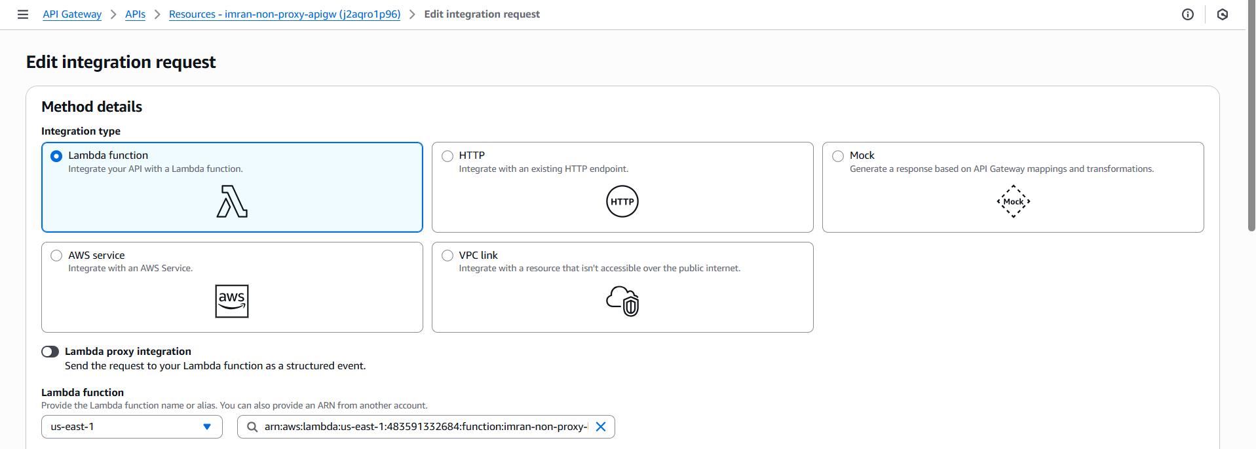
11. And now in mapping templates write the code .
12. 
13. Now test and deploy take new stage with name dev
14. 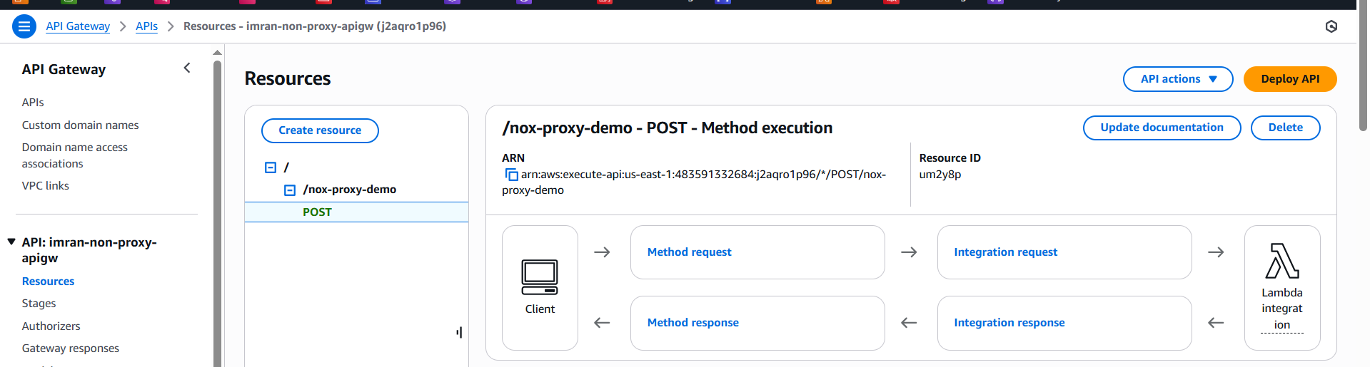
15. 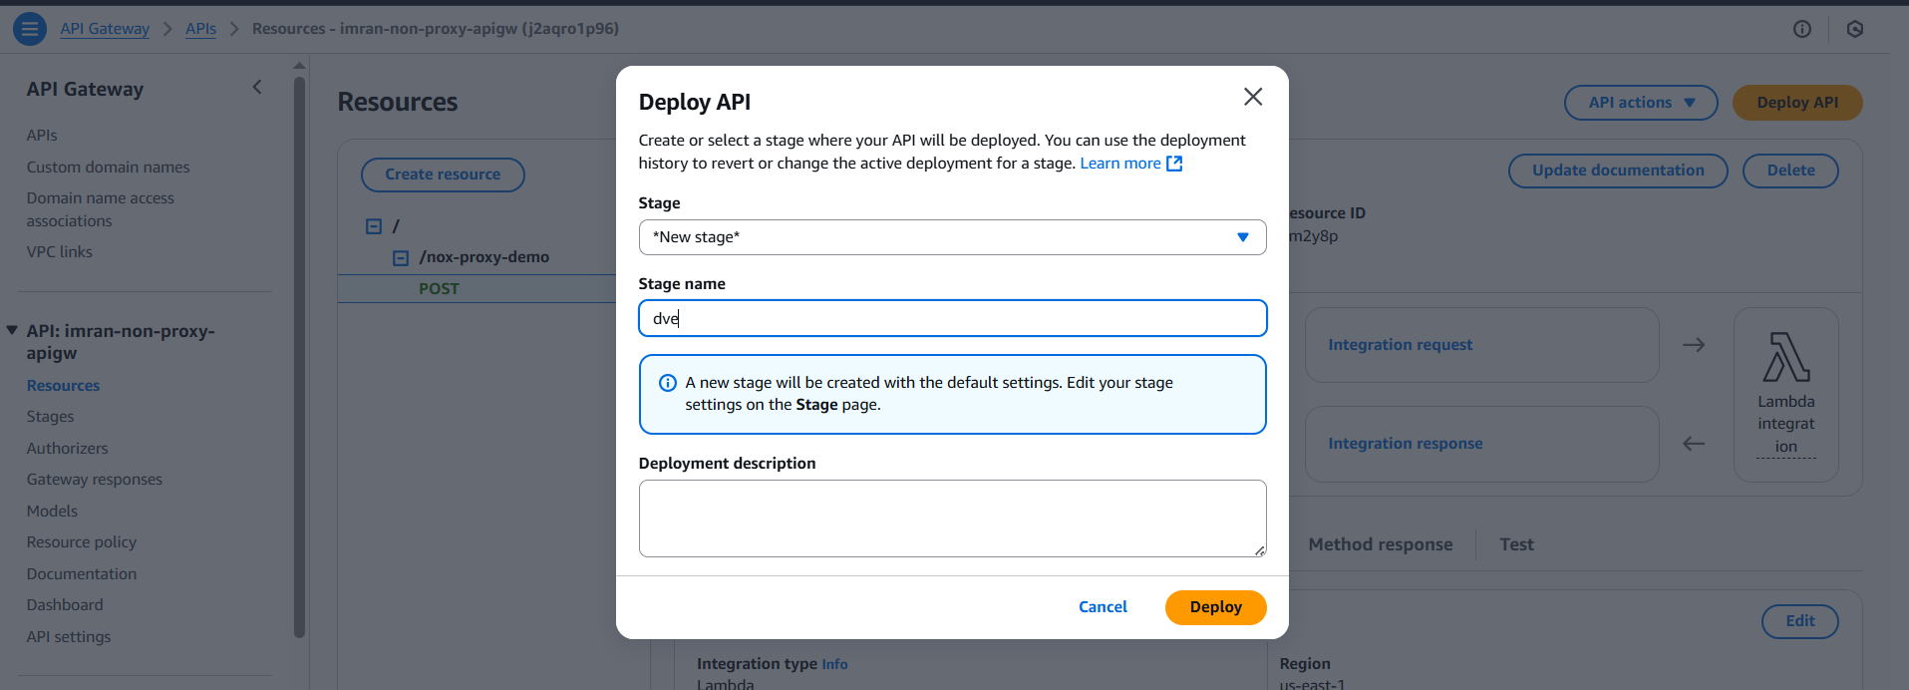
16. Take the url
17. 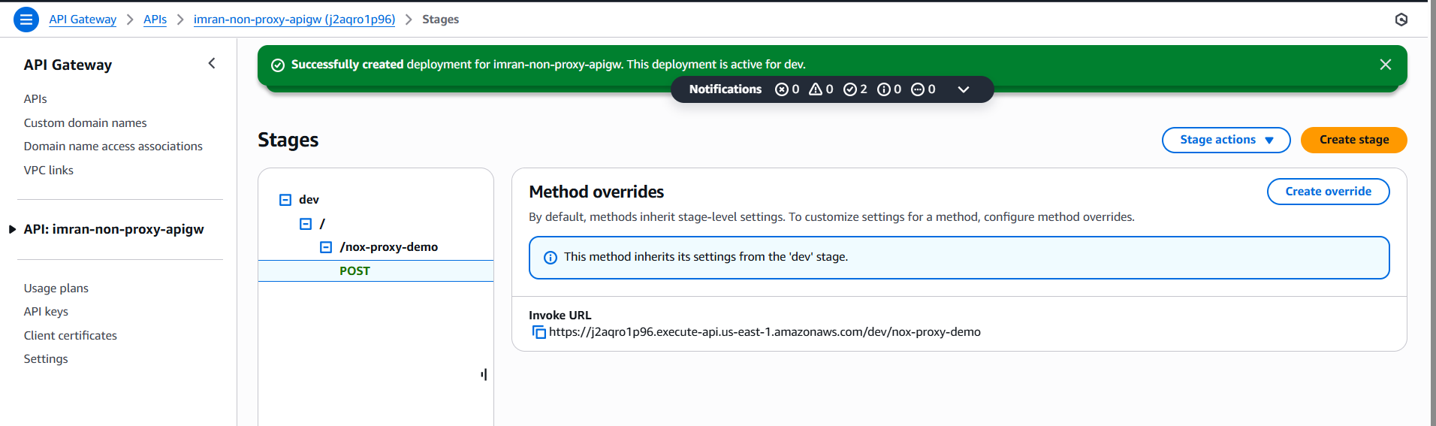
18. Now check in postman app with the post method you can add name and value
19. https://j2aqro1p96.execute-api.us-east-1.amazonaws.com/dev/nox-proxy-demo
20. 